Interested in joining or just

want more information?

Contact
The South Australian
Bonsai Society
www.bonsaisa.org.au

Meetings are held at:
Goodwood Community Centre
32 Rosa Street
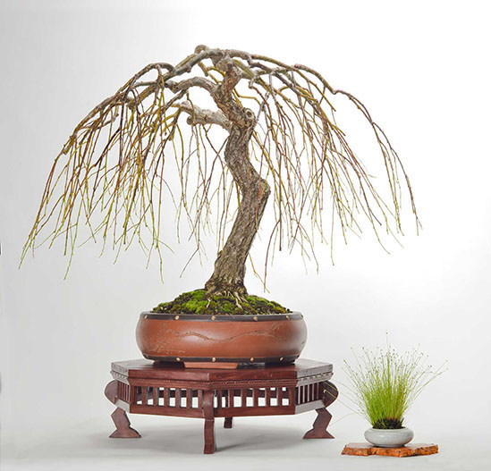
GOODWOOD SA

Members participate in monthly meetings and workshops.
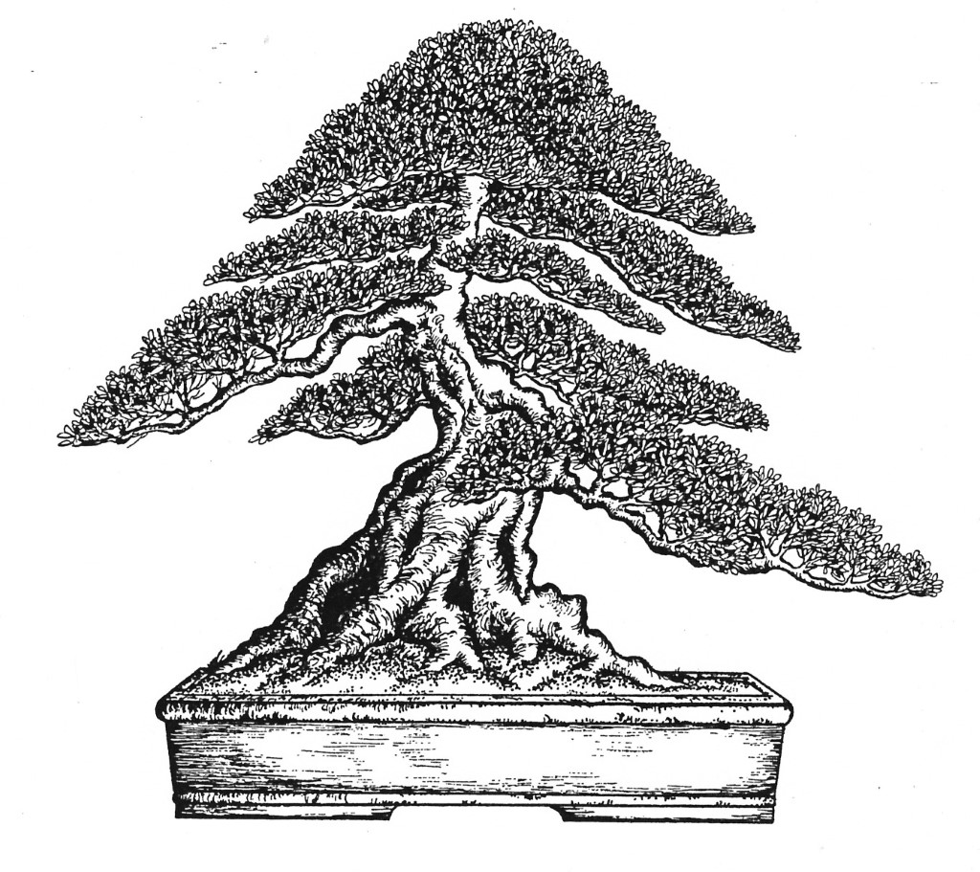
Digs are arranged in the autumn/winter to enable members to collect free stock – a fun way of expanding a collection.
The annual Bonsai Show is held in October.
A Guest Tutor Program provides weekend workshops and demonstrations with a nationally recognized bonsai demonstrator.

Meetings are held
The South Australian
Bonsai Society
Incorporated
1st Tuesday of the month – February to December starting at 8-00pm
- Members exhibit trees in Novice, Intermediate and Open Sections
- Demonstrations, guest speakers
- Extensive library of bonsai related books, magazines and DVDs
- Trading table for wire and tools

Workshops are held
3rd Tuesday of the month – February to November starting at 7.30pm
- Learn through shared experiences
- Members bring trees for advice from more experienced members who suggest and help with design improvements
- Beginner’s classes

President: Matt Sharp
Secretary: Annie Reid

www.bonsaisa.org.au

The art of Bonsai or the growing of trees in miniature commenced in Asia centuries ago.
The word bonsai comes from two Japanese characters – bon – meaning pot or tray and – sai – meaning tree. Hence tree in a pot.
The Western world has adopted the art as a pastime and it offers healthy relaxation from a busy lifestyle. Bonsai specimens are normal trees and plants – they must be kept outdoors, although they can be brought inside for a few days at a time for decoration purposes. The shallow containers dry out quickly and need some shade during the summer months.
Watering can be done by immersion or overhead sprinkling. Half strength organic fertiliser can be used during the spring and autumn or a slow release fertiliser can be used throughout the year.
The culture of Bonsai is considered a real art and its main aim is to acquire an appearance of age and to cultivate a miniature specimen similar to one which can be found in nature.
Branches are wired to the desired shaped, the wire being removed once the shape has set and before the wire begins to cut into the bark. This may be two months or two years, depending on the age and type of trees. Prune and pinch back the foliage so that it does not extend beyond the design. This is a constant task during the growing season as the tree can soon lose its shape.
Bonsai need to be root-pruned and re-potted to be kept healthy. For most trees, this is done during late winter or early spring when new growth is about to commence. Study books on the subject or join the SA Bonsai Society, and then – with an eye for what is possible, specimens can be selected from nurseries.
Many varieties can be commenced from seeds, cuttings or seedlings found beneath large trees.

Trees suitable for bonsai in Adelaide include:
Flowering and Fruiting
Bougainvillea
Cotoneaster
Crepe Myrtle
Azalea
Hawthorn
Wisteria
Crab Apple
Pomegranate
Plum
Apple
Quince

Native
Ficus
Grevillea
Melaleuca
Leptospernum
Lily Pilly
Bottle Brush
Casuarina

Evergreen
Olive
Juniper
Chamaecyparis
Cedar
Yew
Cupressus
Box
Privet
Coprosma
Pines (Black, Mugo,
Aleppo, Radiata)

Deciduous
Elm (Chinese, English)
Ash
Oak
Zelkova
Gingko
Liquidamber
Maples
Payment options for your subscription to join the Bonsai Society

FTPOS facilities are available for payment when you attend a meeting of the society.
* Remember to present a completed application form when making payment.

Direct debit for Bendigo Bank:
BSB 633-000
Account 152540431
* Please present a completed application form at the first meeting you attend.

Cheque: Make payable to The South Australian Bonsai Society Inc, with the completed application form and post to:
The Secretary - The South Australian Bonsai Society Inc
PO Box 159
GOODWOOD SA 5034

desire to become a member of The South Australian Bonsai Society Incorporated. In the event of my admission as a member

Signed ___________________________
I agree to be bound by the Constitution of the group.
Country $20
Address___________________________________________________________________________________________________
Suburb _____________________________________________________________________________ Postcode _____________
Student $20
I, (Mr/Mrs/Ms/Miss) First Name _______________________________
Family $50
Please tick appropriate membership
Surname ___________________________________
Single $40
Email ____________________________________________________________________________________________________
Telephone (H) ____________________ (Mob) ____________________ (W) ___________________

